

CPE 695 Final Project

**User Trajectory Profile Report**

Dec 21, 2016

***I pledge my honor that I have abided by the Stevens Honor System.***

Overview

There are mainly 6 parts in our project:

* User data download and data filtering
* OpenStreetMap download and matching with Twitter data
* Integrated Data processing
* Data Analysis and location prediction
* Web server architecture building
* Trajectory mapping and analysis
* Tweets data Visualization -D3.js

The framework of our work please see Figure 1.

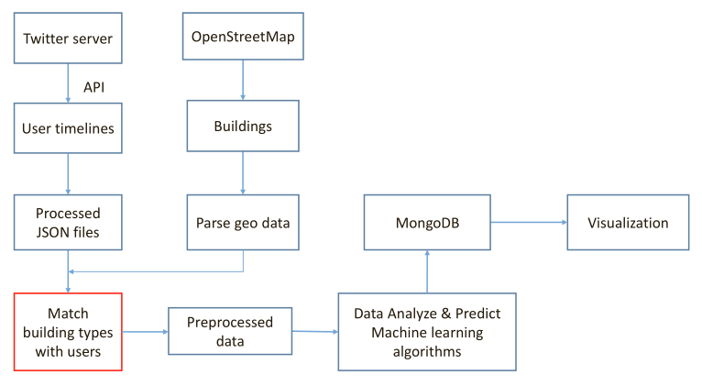

Figure 1 Project Framework

User data download and data filtering

**Data download**  
Methods: register for OpenStreetMap and download data of New York City using QGIS. Figure 2 and Figure 3 show the data download from internet.

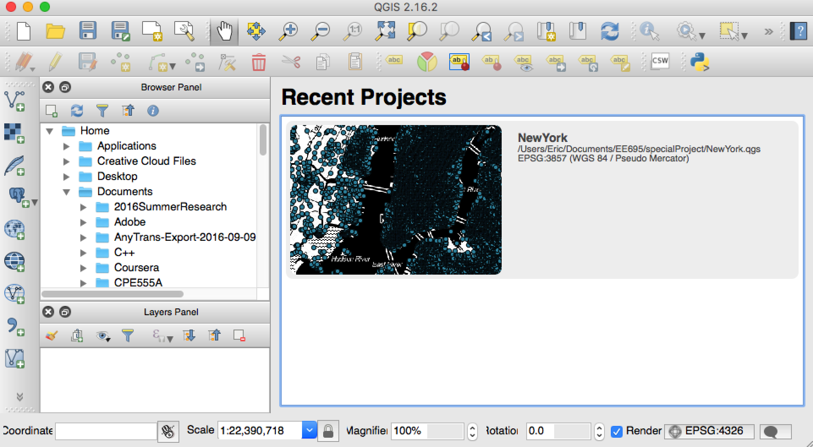

Figure 2 QGIS Usage

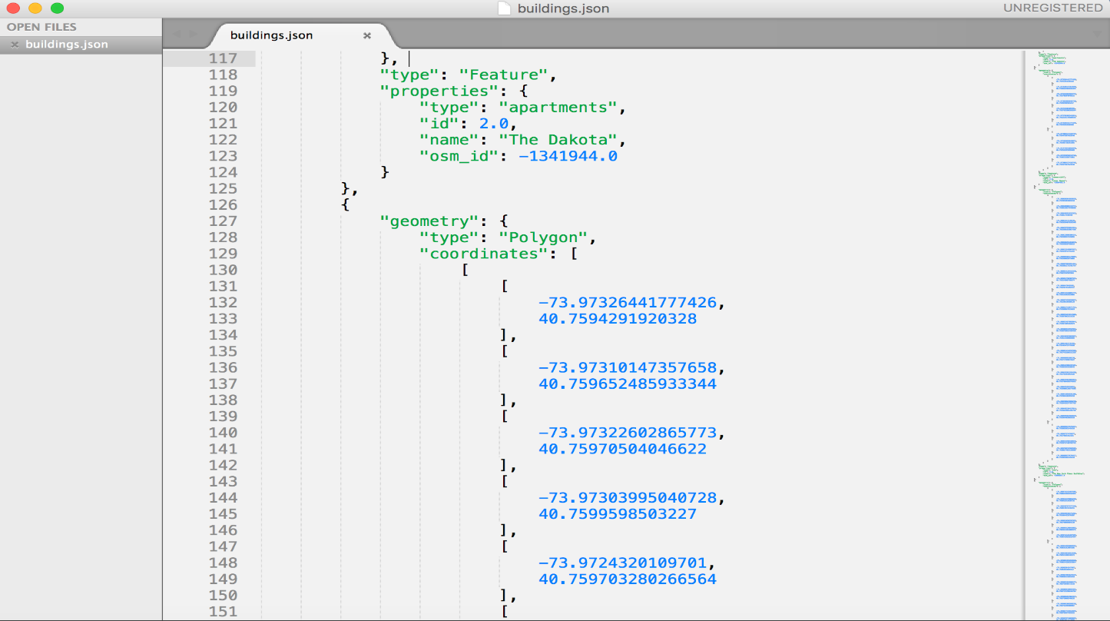

Figure 3 Tweets data

User selection  
Keep tracking tweets being posted within New York area for an hour and select all the tweets tagged with geolocation.(TweepyStreaming.py and geoProcess.py)  
Match building types with each tweet by coordinates(building_match.py and match.py) and get the most common 10 building types that are matched(termFrequency.py and building_type_freq_NewYork.txt)  
Select tweets with building types that belong to the most common 10 types and get the users’ ids from the tweets.  
Then randomly select 100 user for prediction(userFilter.py)  
  
 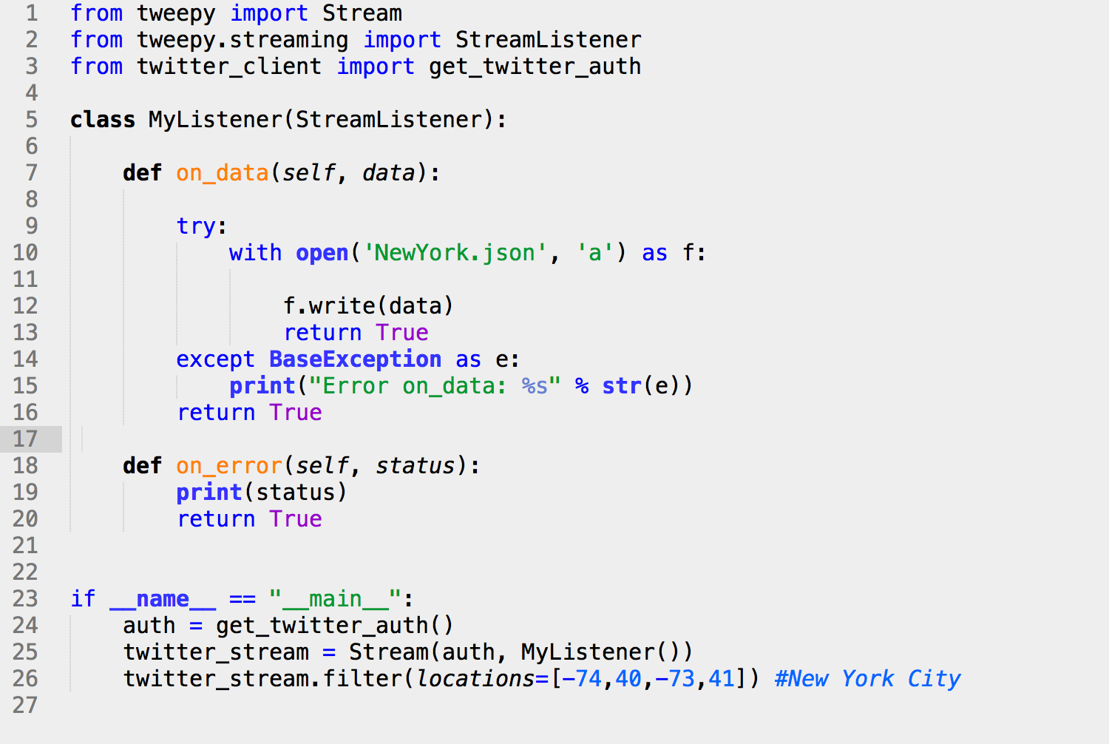

Figure 4 TweepyStreaming.py  
  
  
  
  
  
  
  
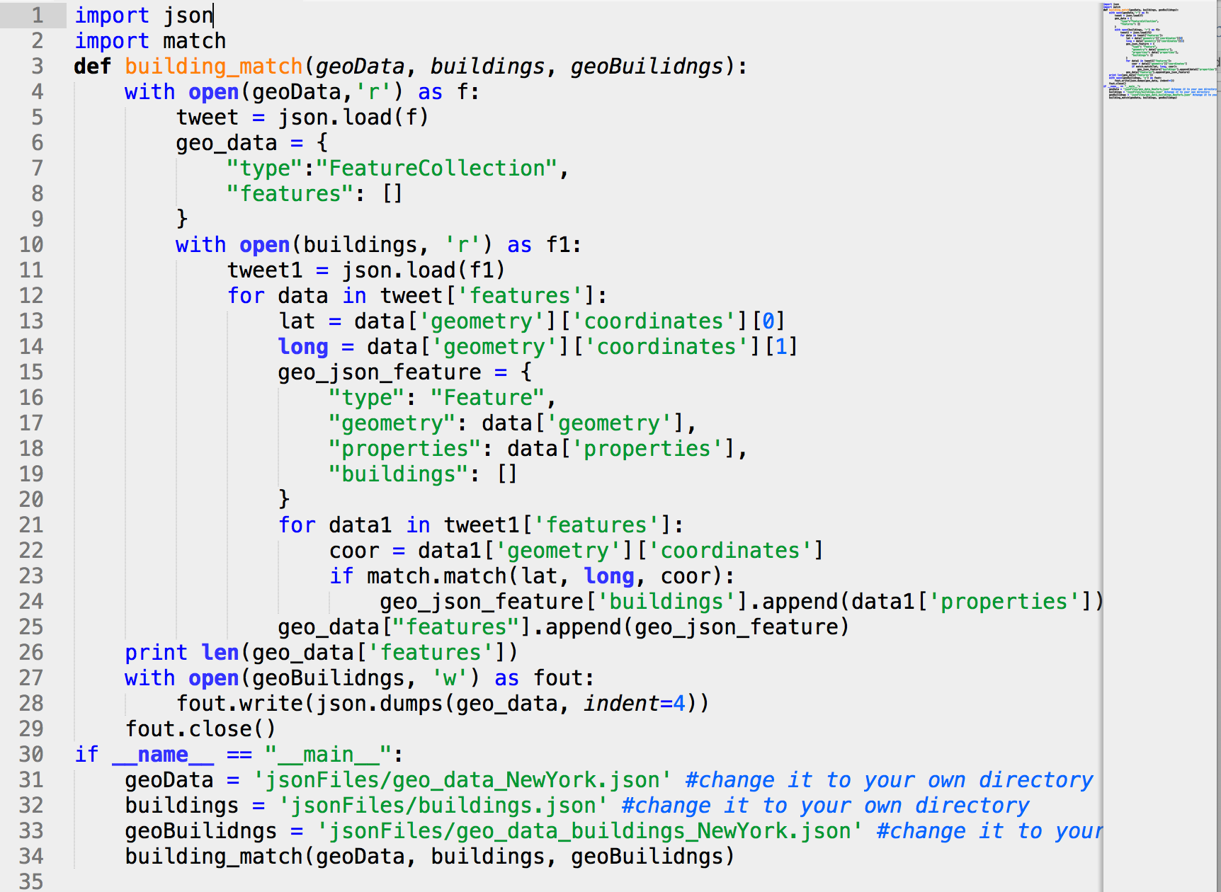

Figure 5 building_match.py  
  
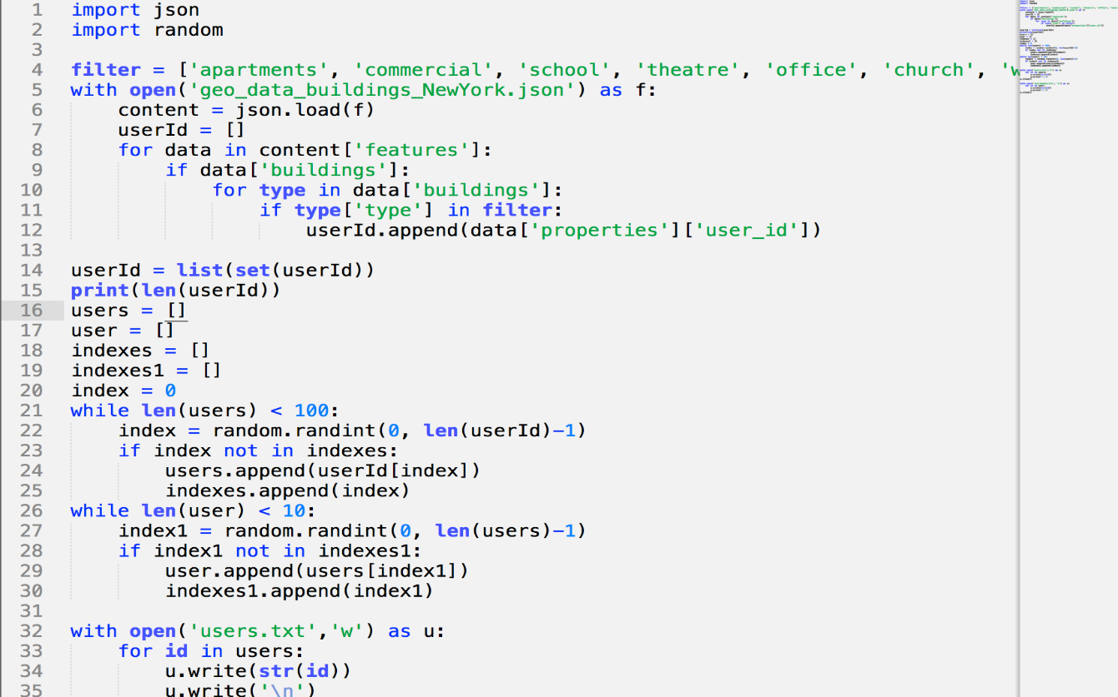  
Figure 6 userFilter.py

Get user timelines

Get the most recent 1000 timelines of all the 100 users selected.  
 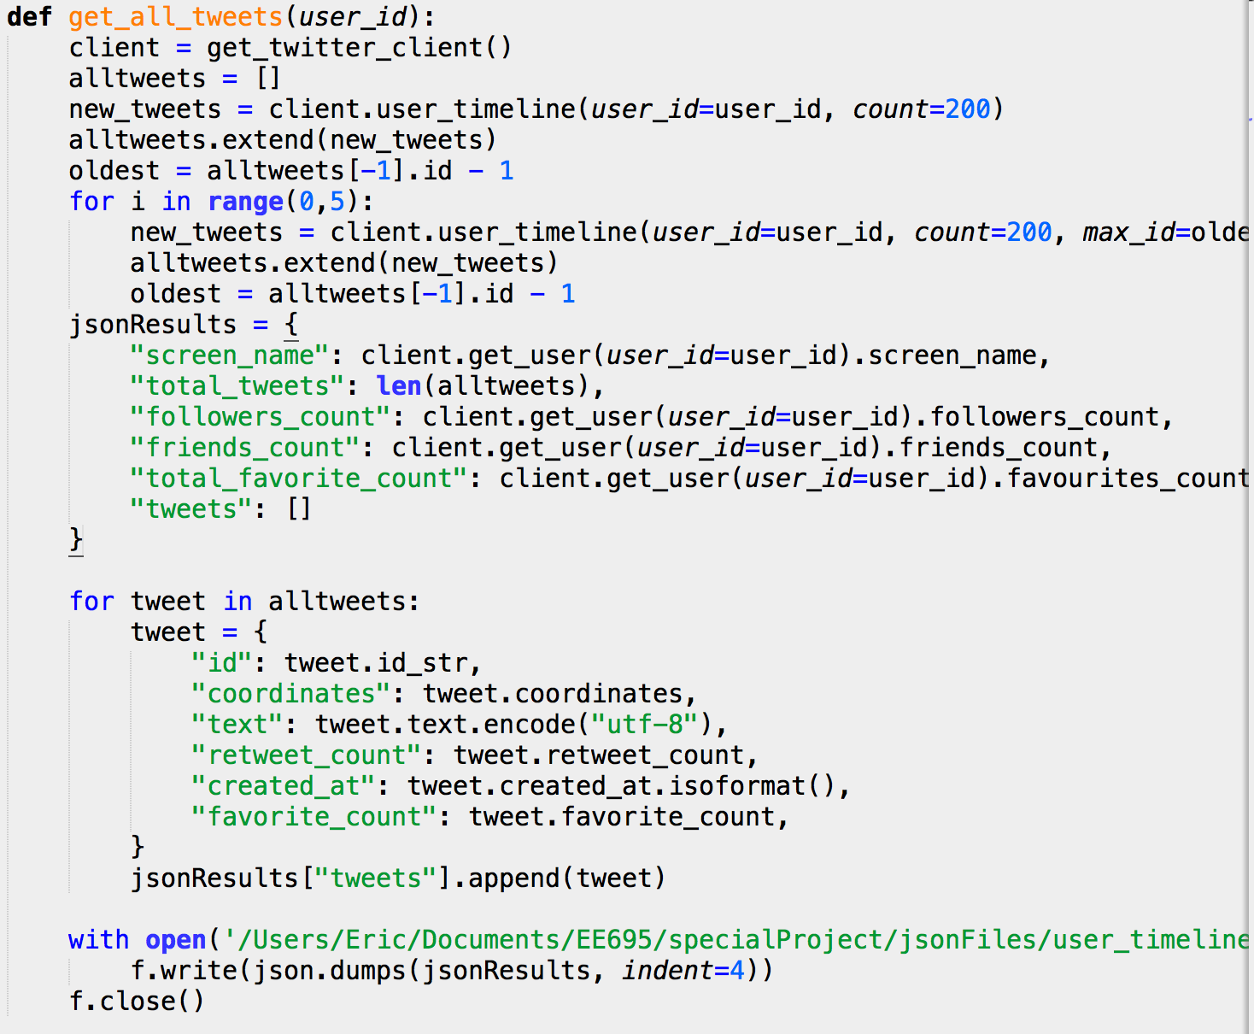

Figure 7 twitter_get_user_timeline.py

Match building types again with each tweet(add_building_to_user.py)  
Filter out tweets that are not good for prediction and write the final result to json files.

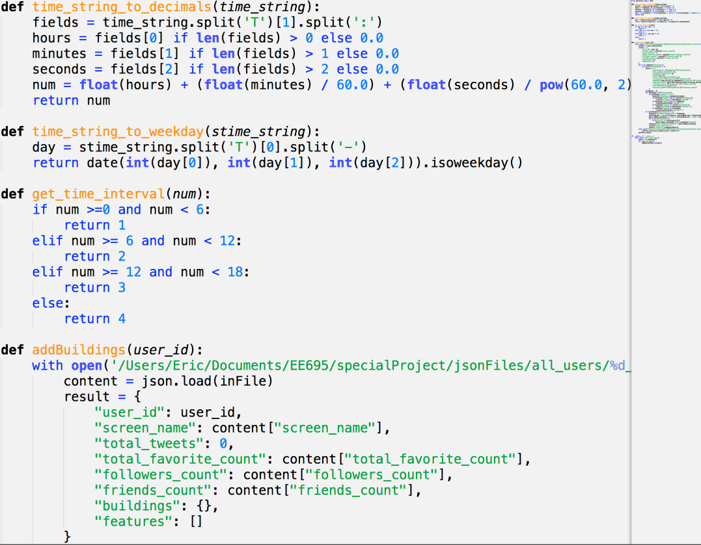

Figure 8 add_building_to_user.py

Store the final data to MongoDB(store_twits.py).

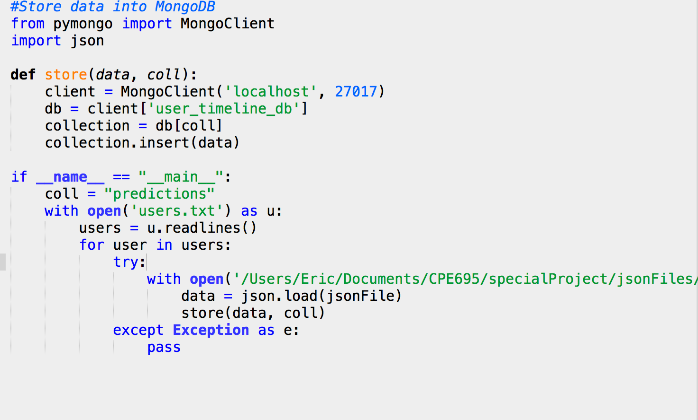

Figure 9 store_twits.py

Flask web server   
Project Framework

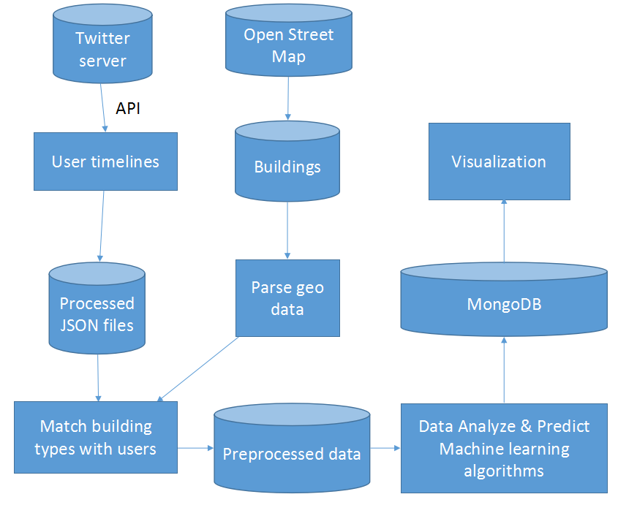

Figure 10 Framework

First we download users’ tweets data form twitter using its API, stored all data in local database as JOSN files. On the other hand, we download Open Street Map polygon file, transfer it from .csv file into .json file, and parsed it for future use. After finish previous two steps, we developed an algorithm to match users’ location with OSM geotags(building type, coordination) and combine these data to a new JSON file, stored in local Mongo database. Next, our data analyze team used its own algorithm to parse all data and got results, stored them in a new collection in local database. Last, we implemented a web service, it requires data from database and shows all result for each twitter user’s location history and prediction of his next tweet on the map, as well as some other data static shows in data visualization way.

Architecture of web service

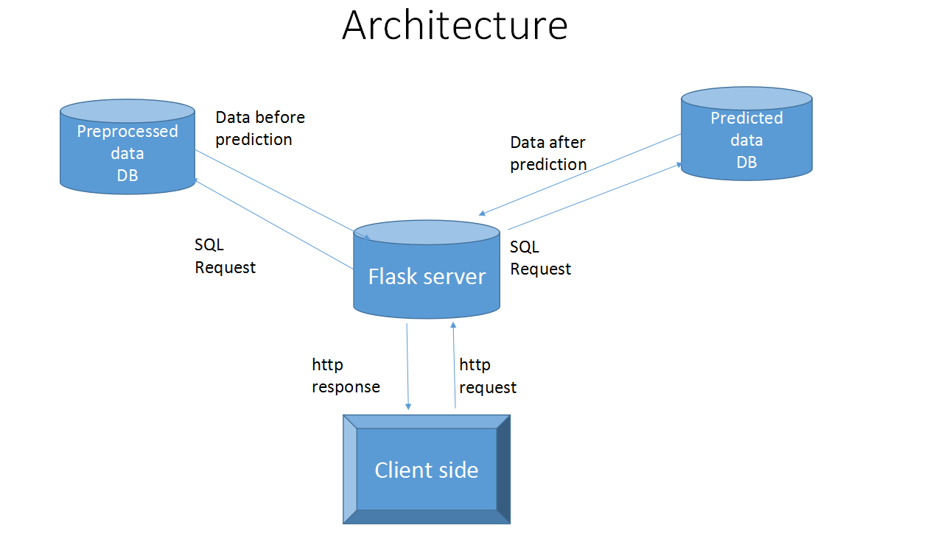

Figure 11 Arhitecture of web service

We implement our web service using flask framework, B/S architecture. There are 2 different collection in our server database, one is stored data before prediction for provide the data for each user’s tweets history for display and data analyze, the other one is stored data after parsed for provide prediction result and display them on website. The processes of our web service is: First the client side(browser) sends a http request to server, after the server received it, it sends sql queries to database and gets result from database, then sends results to front end using http response. Last the front side parses the data it received and displays them on your browser.

Data Analysis and location prediction

Introduction

Our group project is user trajectory profile which collects users’ information, visualizes it and does the prediction on his future locations. I am responsible for the prediction part, using AR model and R language.

AR model: 

X­­m represents the pth time period’s data, an represents different weights and ∈t means the noise at the tth time period. (t-p≤m≤t, 0≤n≤p)

AR model is often used on time series and it considers that the information in future can be concluded by past information using the formulation above.

Process

At the very beginning, I am given CSV files which contain users’ longitudes, latitudes and times. The information is in character format which, however, cannot be processed directly by my AR model. Therefore, I need to abstract the numeric information from the original things, see FIG. 12.

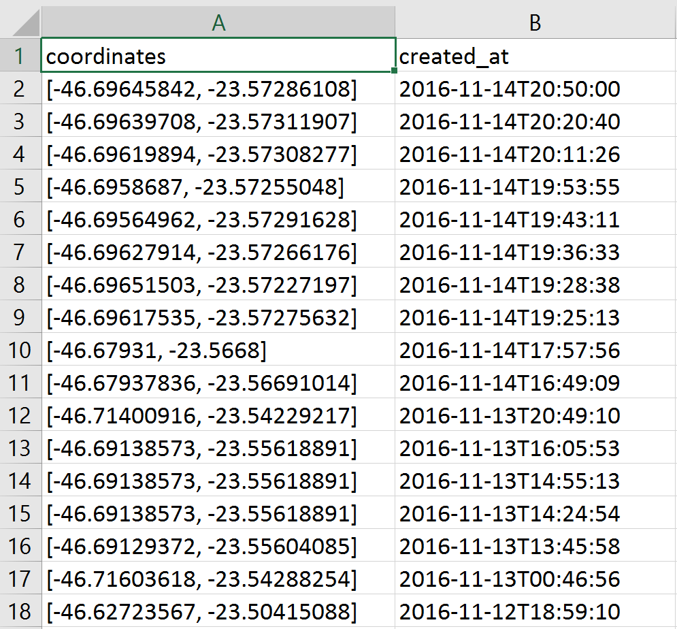

Figure 12 User data

Here I use the character split function to redefine the information as three new datasets. ‘train1’ is longitude, ‘train2’ is latitude and ‘train3’ is time transformation. See FIG. 13.







Next, I divide time into four parts: 0-6am, 6-12pm, 0-6pm, 6-12am. The reason why I make time division is that my model requires equal time period to analyze data. In real situation, the information from 0 to 6 pm is always in lack because most people are sleeping. So I ignore the information in the period even though there are still few records over there.

Then, I classify longitudes and latitudes according to time division. In other words, I put the longitudes and latitudes in their own time period. If there are plural records in the same period, an average is used. In this way, I get another two new datasets showing their location information. The length of the datasets is three times of the day amount. After that, what I need to do is to handle the NA values in datasets. Here I use the mean to replace them.

‘c’ in the below represents the number of days and ‘p’ means time periods which is three times of ‘c’:

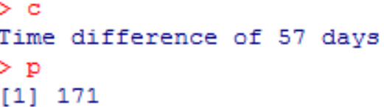

‘pel’ and ‘peh’ are datasets of longitudes and latitudes after classification, still some NA values in them.

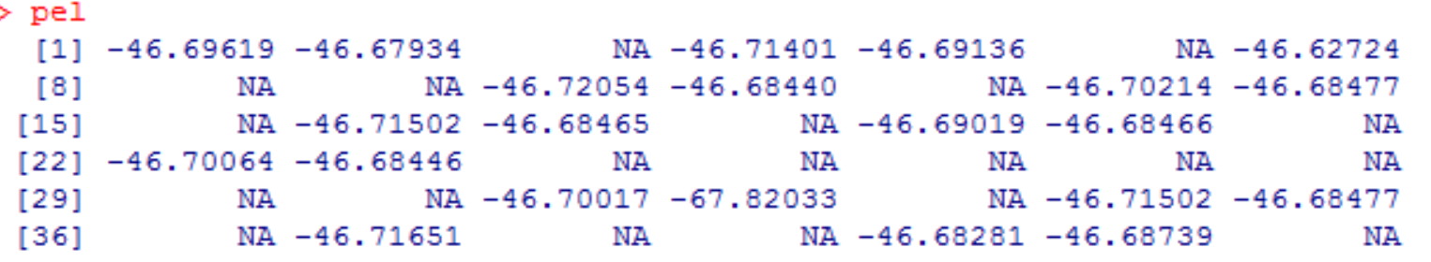

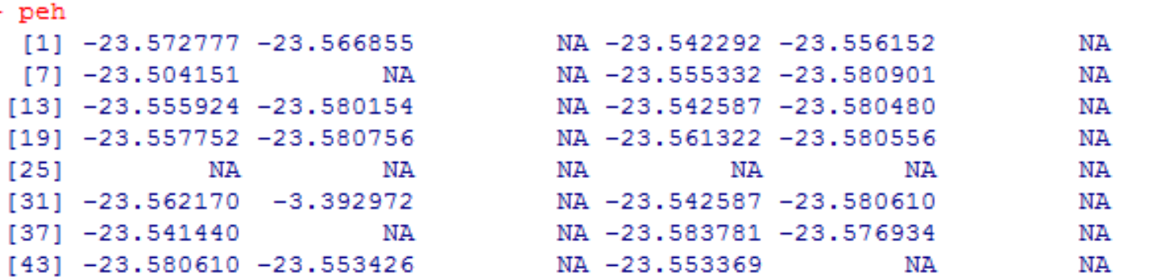

‘newpel’ and ‘newpeh’ are the back-to front datasets of the original datasets with NA values replaced by mean. The reason for back-to-front transformation is that the first data of ‘pel’ and ‘peh’ is the latest data and the prediction only follows the last data. Sequence should be adjusted if we want to get future information.

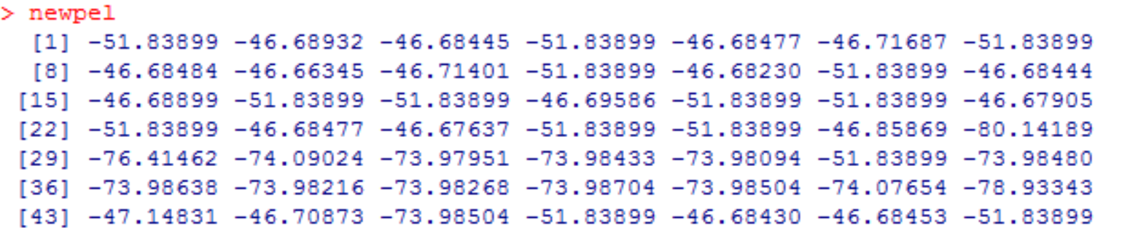

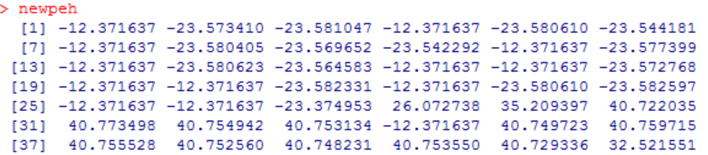

To lower the error caused by replacing, I do a three-lag difference since three periods represent a day. Then I use AR model on the two latest datasets. By using the package about ARIMA and ACF in R, I find three- lag AR model should be used for those sets.

‘newpel2’ and ‘newpeh2’ are AR models of longitudes and latitudes respectively.

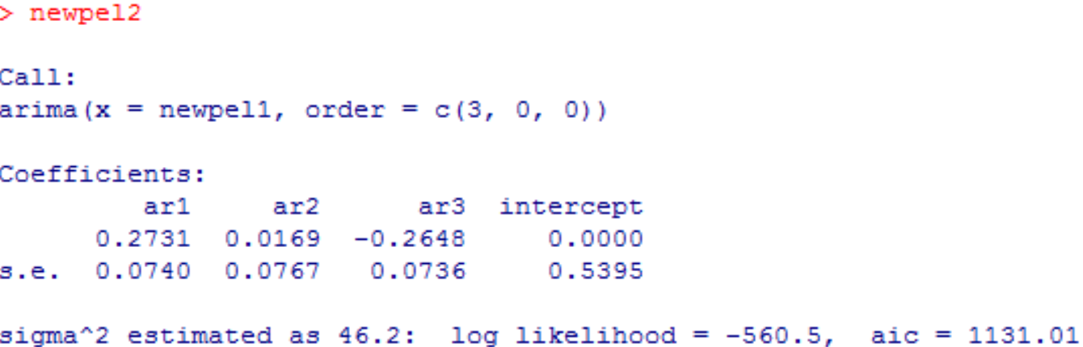

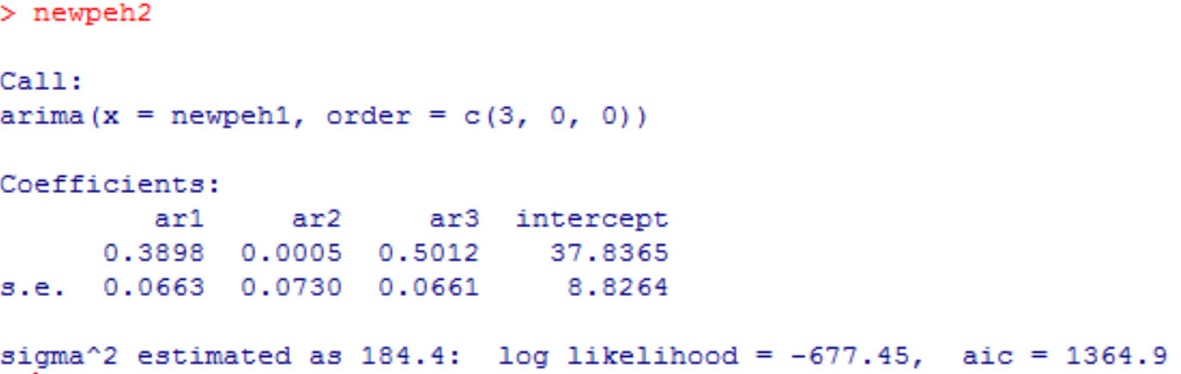

Three- lag AR model should be used for those sets.

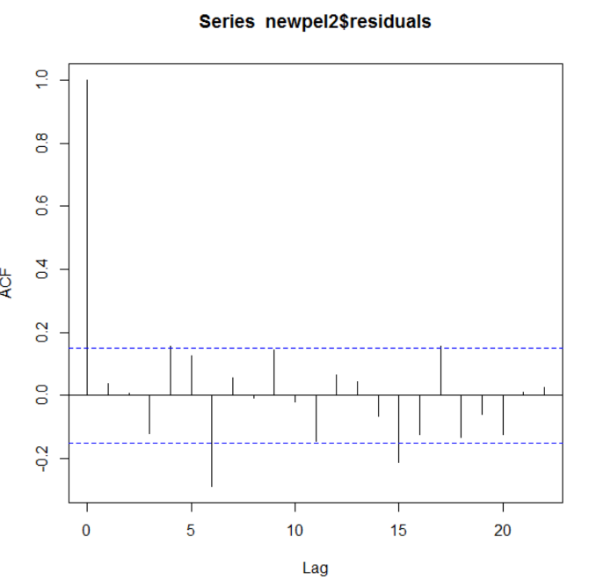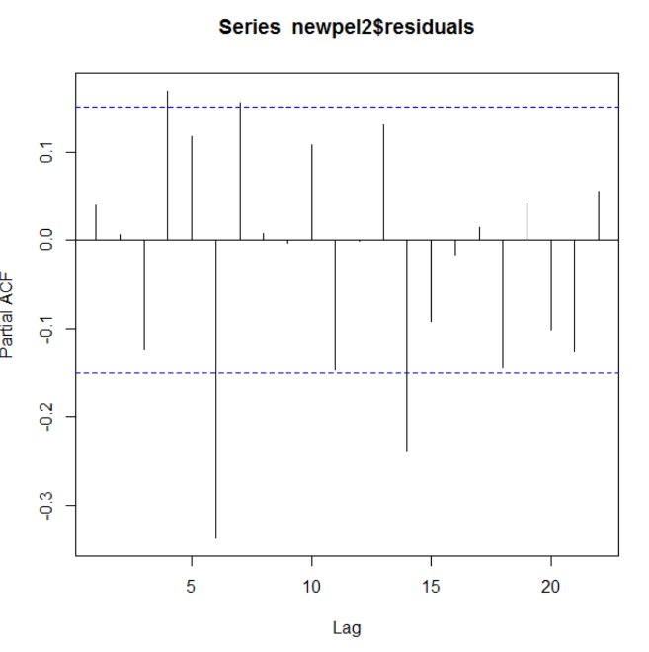

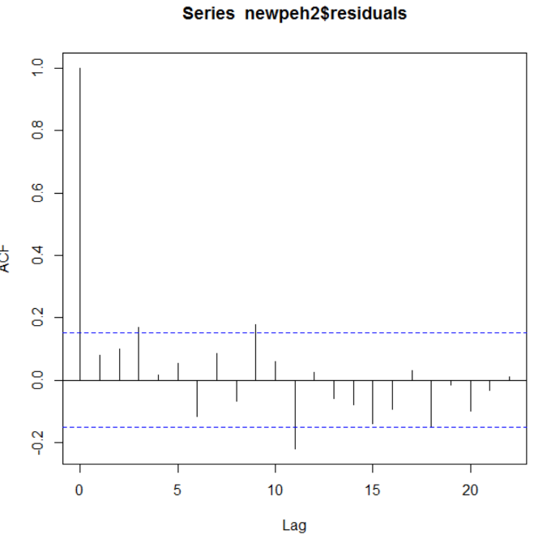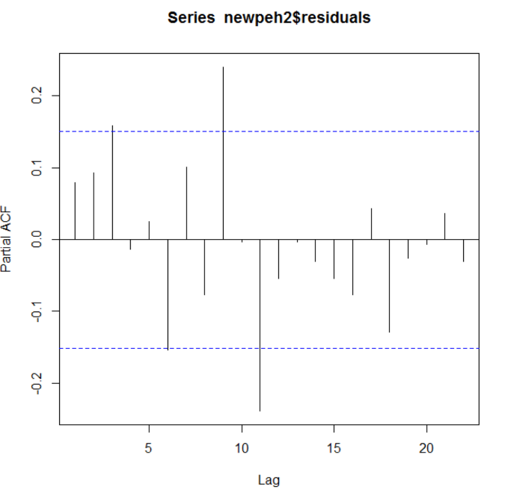

Figure 13 Prediction Model

The prediction by model(FIG. 13) often refers to a place that the user has never gone to before. To make it more precise, I calculate the distance between prediction and the points nearby of the users’ past. I list the first five points as the final results. In this way, I successfully shrink the results’ range and make them more reasonable.

Seq1, seq2 and seq3 are the ranks of the difference between prediction and points nearby. The first number shows where the minimum is and the last number shows the position of maximum. Using this way, I can find the closest 5 points near prediction.

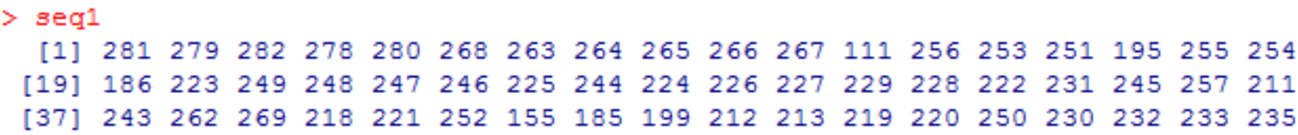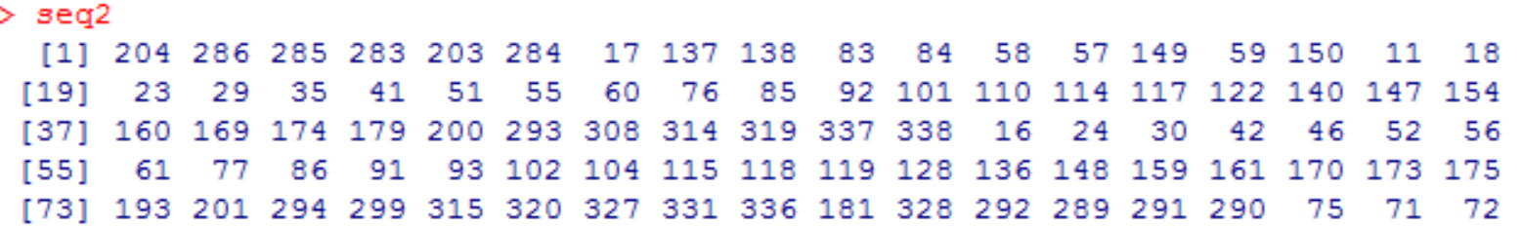

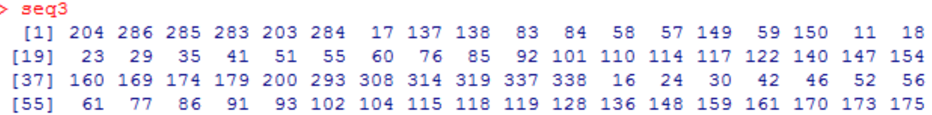

Results

My output is CSV files. Row 1 is 6-12pm, row 2 is 0-6pm and row 3 is 6-12am. V1, V4, V7, V10, V13 are longitudes. V2, V5, V8, V11, V14 are latitude. V3, V6, V9, V12, V15 are possibility. Each time period of the same day has 5 points, see FIG. 14.



Figure 14 Prediction results

Problems

My accuracy is low and I have tried many ways to adjust the whole system. There are still some problems I cannot handle even though I can know how it happens.

a. Too many missing values.

Too many NA values are replaced by mean in which case the results will be forced around mean even though I have done 3-lag difference on datasets.

b. AR model is not suitable.

For some datasets, AR model may crash due to singularity. Because of it, the loop in my program may stop and need to skip this dataset artificially. Another model need to be added to handle those special datasets. AR model is not the best choice.

c. Points nearby

It may be usual in my results that for the same user, two different time periods may share the same five points. The reason is that the original prediction changes a little and is still close to the same point. And the difference between their possibilities is so small that I can ignore it.

Trajectory mapping and analysis

Tools

We use two tools here: Leaflet and Geany.

Leaflet is a JavaScript library for interactive maps. It’s a powerful tool for building [web mapping](https://en.wikipedia.org/wiki/Web_mapping) [applications](https://en.wikipedia.org/wiki/Application_software). Please see Figure 15(a). Geany was developed to provide a small and fast IDE, which has only a few dependencies from other packages. It supports many filetypes and has some nice features, see Figure 15(b). Here we use it to develop JavaScript codes.

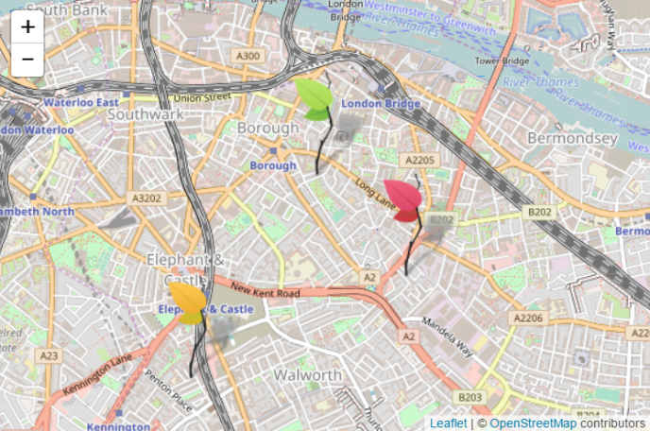 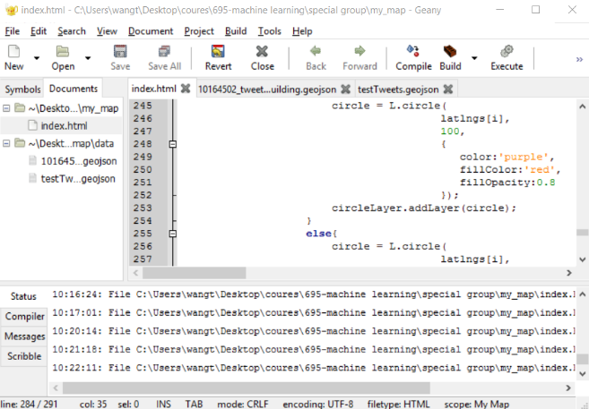

1. Leaflet (b) Geany GUI

Figure15 Tools for mapping

Data Reading

There are two ways to get the users geometry data- One is from local MongoDB server, the other way is from local json file or geojson file. In the project, we test the data using json and geojson file. And read the prediction data from in MongoDB server. Here we show how to load geojson file.

GeoJSON is a format for encoding a variety of geographic data structures. Its format is as followings:

{ "type": "FeatureCollection",

"features": [

{

"geometry": {

"type": "Point",

"coordinates": [-73.98656309, 40.75688403]

},

"buildings": [Times Square],

"type": "Feature",

"properties": {

"text": "I'm at Auto Posto Ilha Do Sol https://t.co/8rNkwrc0r1",

"created_at": "2016-11-02T20:59:22",

"retweet_count": 0,

"id": "793920458697666561",

"favorite_count": 0,

}

}

]

}

The GeoJSON data represents geometry, feature, and a collection of information of Twitter users. Leaflet has a function called *L.geoJson*, which read the geojson file literally. We can easily add markers of coordinates and popups for information of users. See Figure 16.

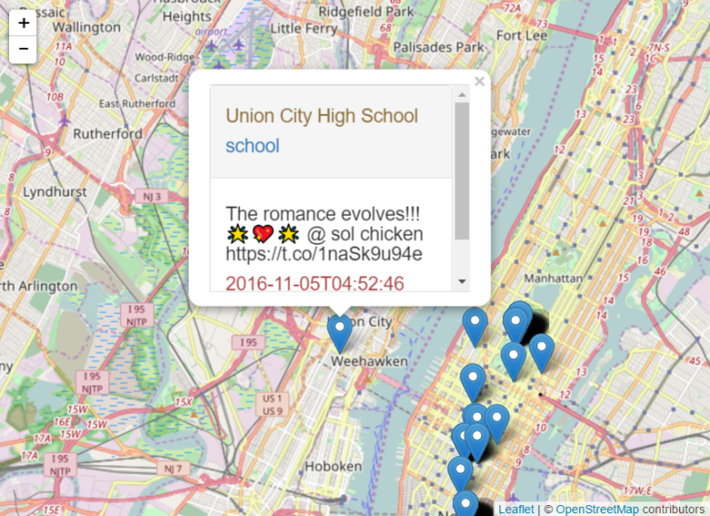

Figure 16 Markers and Popups

In the picture, the map is parts of OpenStreetMap of New York city. The markers represent the places that the user had once visited. The content in the popup represents the users’ data. Union City High School in the popups is the building name. And school in the second line is the building type. The scripts and time below are the information of tweets.

Location visited frequency rank

Location visited frequency rank is an algorithm we develop to find the top 10 places that one user always visited. The flowchart please see Figure 17(a). The algorithm detail is as follows:

1. Read data from geojson file and store them in an array A.
2. Build an object, which contains coordinates, the order of the data, and the frequency of the coordinate.
3. Store first the object in a new array B, and compare its coordinates with all the other coordinates in array A. Once found a coordinates has the same value as it in the object, add the frequency one time.
4. Store the second and the rest of all coordinates in array A into the object one by one, and do the same process as the one in step (3).
5. Ranking array B, set the top 10 most visited locations as large icon for the markers, and the rest locations as small icons.

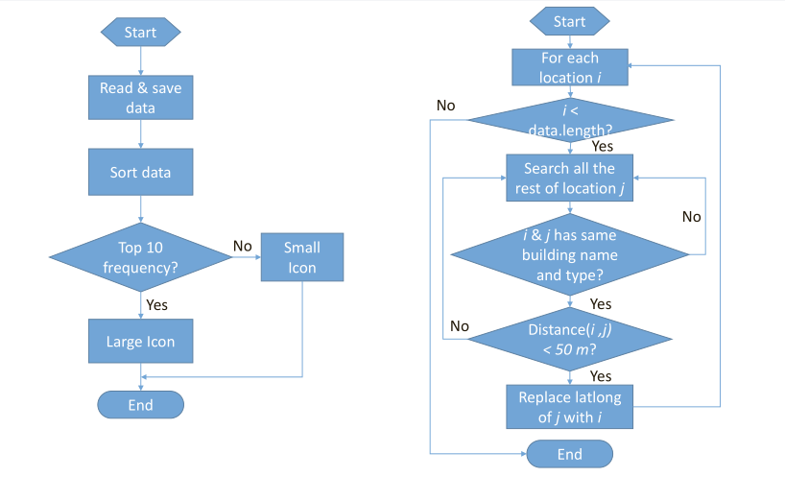

1. Location frequency rank (b) Location integration

Figure 17 Algorithms

Locations integration

Locations integration refers to make the locations that near to each other to be the same one. This method is to optimize the user’s trajectory. The algorithm flowchart please see Figure 17(b). The details are as follows:

1. Start from the top 10 locations, pick one to compare with all the rest locations. If they have the same building name and building type, and if their distance is less than 50m, replace the coordinates with the value of picked one.
2. Loop all the locations to finish the comparison in step (1). **Note**: the coordinates cannot be replaced if they belong to the top 10 locations.

The location integration can make the map look simple. That because it can delete the markers which actually belong to the same place. But there is a problem here, if the geojson data doesn’t contain specific building name or building type or both, the algorithm here will consider some locations as the same one and save only one of them, which actually are the different locations.

Results

Here we have 6 layers on the map- Google Earth layer, Google Road map layer, OpenStreetMap layer, Tweets, lines(Trajectory), circles layer. All the layers show different views and functions. Please see Table 1.

By clicking the button on the right top side of the map, we can switch between layers freely. The Tweets layer shows all the location that one user had ever been before. Lines layer show the user’s trajectory, the more lines converge in one place mean the more frequent this places have been visited. The circle layer shows the frequency directly. The large circles on the map means the top 10 most frequent visited places.

Table 1 Layers on the map

|  |  |
| --- | --- |
| **Layers** | |
| C:\Users\wangt\AppData\Local\Temp\1482371406(1).png | C:\Users\wangt\AppData\Local\Temp\1482371454(1).png |
| Google Earth | Google Map |
| C:\Users\wangt\AppData\Local\Temp\1482371791(1).png | C:\Users\wangt\AppData\Local\Temp\1482371739(1).png |
| OpenStreetMap | Tweets |
| C:\Users\wangt\AppData\Local\Temp\1482371896(1).png | C:\Users\wangt\AppData\Local\Temp\1482371945(1).png |
| Circles | Circles and Trajectory |

Date visualization

Front-end graphic user interface

Client side code to communicate with server to get data needed for date visualization. (like implementing get, post http request using Ajax in client side).

1. For data needed for visualization, client side would be send ajax request to server side to get the data.

For example, the code below would send ajax request to get data.

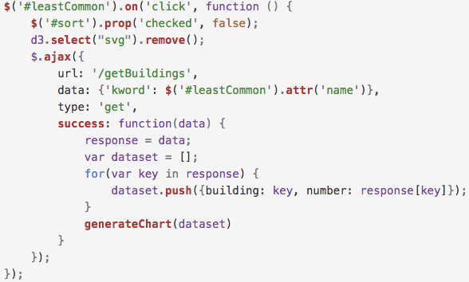

2. For data reform operation, it happens in front end using native javaScript code.

For example, the code below would request data from server using ajax request and sort it in client side.

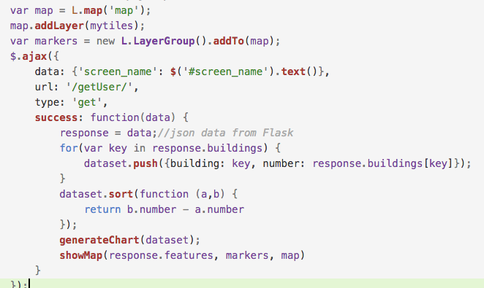

Dynamic charts to show the data in pretty format and show the user(twitter) location in map. See FIG. 18 to FIG. 21.

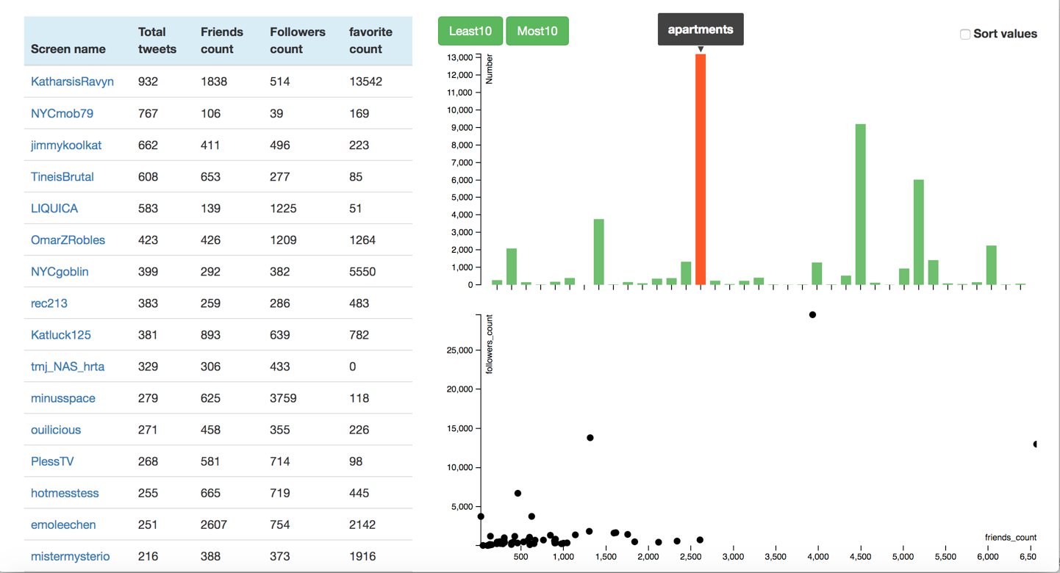

Figure 18 Information of all users

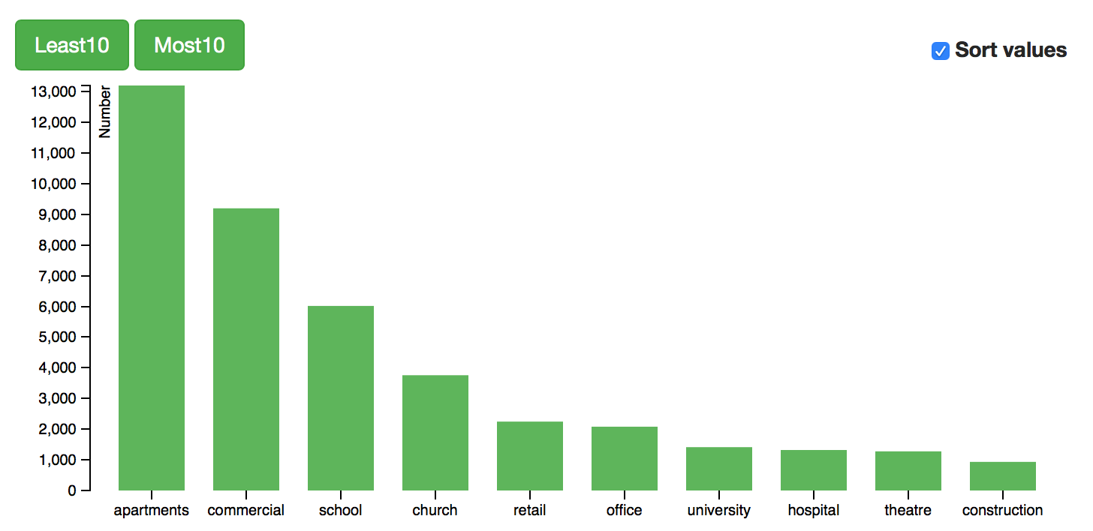

Figure 19 Location frequency of all users

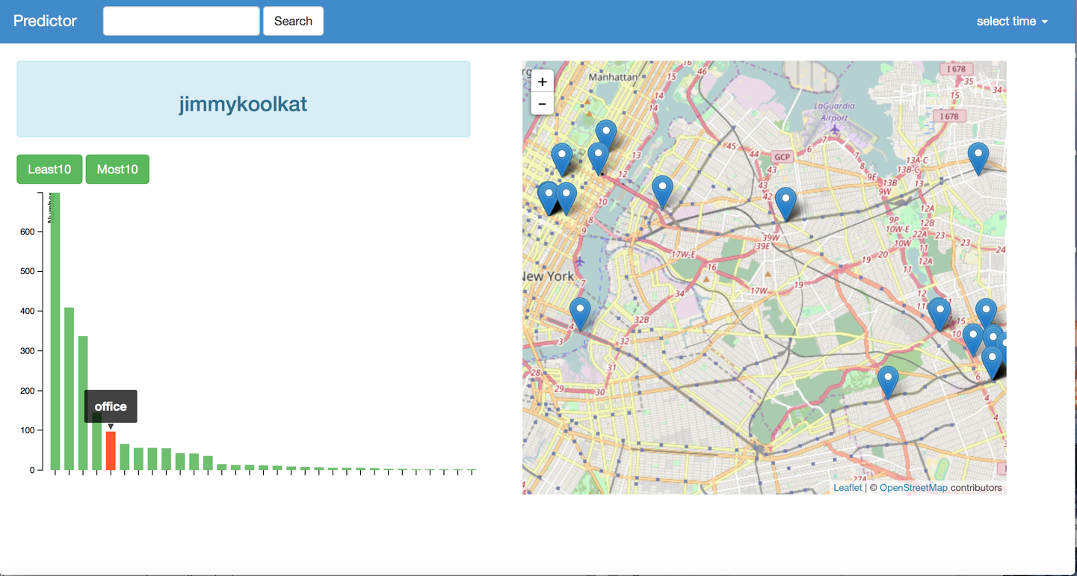

Figure 20 Distribution of one building type

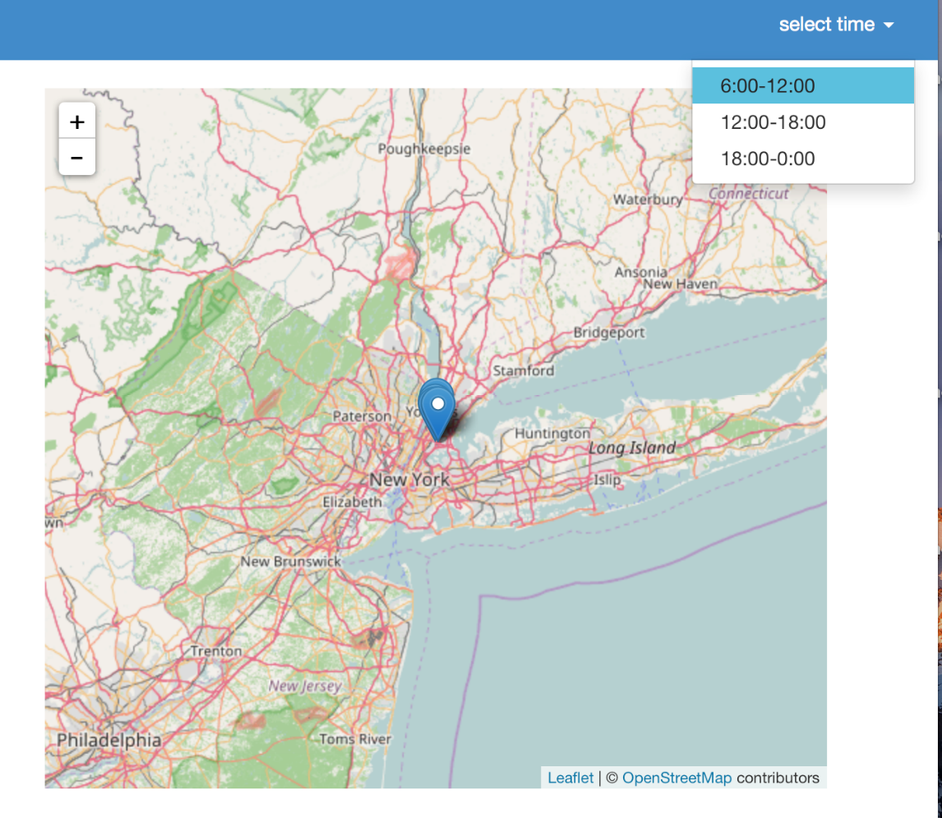

Figure 21 Time interval of one user